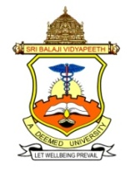
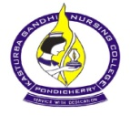
Kasturba Gandhi Nursing College
Sri Balaji Vidyapeeth, SBV Campus
Pillaiyarkuppam, Puducherry - 607402

e-invitation

The Principal and Department of Child Health Nursing

cordially invite you for the

WORLD BREAST FEEDING WEEK – 2020

August 1-7

Theme: Support Breast feeding for a healthier planet
PROGRAM SCHEDULE
WORLD BREAST FEEDING WEEK CELEBRATION –2020
(1.8.20- 7.8.20)
Date | Programs | Participants | Mode | Incharge Faculty
3.8.20 | Essay Competition on Theme  Tamil & English | B.Sc(N)  M.Sc(N)  P.B.B.Sc(N) | GCR | Mrs.SherinNithya.S  Asst.Prof
5.8.20 | Poster Competition on Theme | B.Sc(N)  M.Sc(N)  P.B.B.Sc(N) | GCR | Mrs.Sudha.K.S  Serior Tutor
7.8.20 | Slogan Competition on Theme  (Tamil) | B.Sc(N)  M.Sc(N)  P.B.B.Sc(N | GCR | Mrs.Saranya.S  Asst.Prof

All Are Welcome
**********

