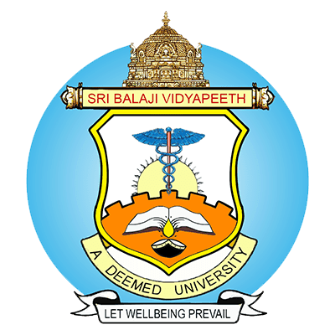
PH.D. RAC CONSTITUTION
Name of the Candidate :
UIN :
Nature of Registration : Full Time / Part time (Internal)/ Part time (External)
Department (place of work) : (M.V.K.IYER Fellowship/JRF at SBV)
Institution :
Date :
Details of RAC Constitution (Maximum FIVE members)
Member | Name | Designation, Department, Institution with full address | Email | Contact No.
Guide
Co-Guide-I
External Subject Expert – I
Internal/ External Subject Expert – II
HOD

Signature of the Guide Dean Research

*Note: (1) CV & Acceptance letter of the External Co-Guide & External Expert should be attached
(2) List of publication for Co-Guide & External Expert should be enclosed within the CV

